**Experiment 1**

Roll no. 4117

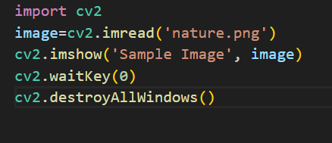

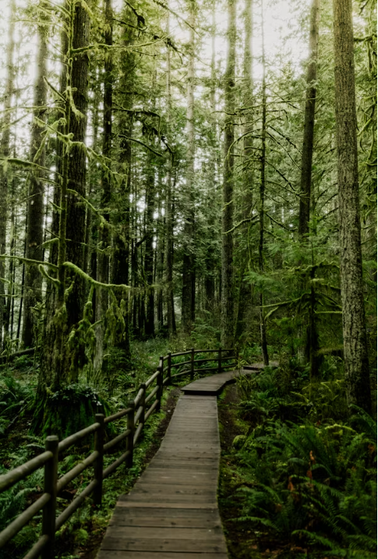

B. ROTATE_90_CLOCKWISE

import cv2

image=cv2.imread('nature.png')

images = cv2.rotate(image, cv2.ROTATE_90_CLOCKWISE)

cv2.imshow('Sample Image', images)

cv2.waitKey(0)

cv2.destroyAllWindows()

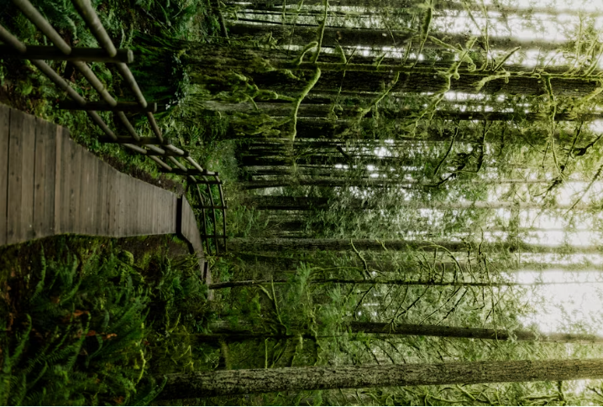

c. Flip the images

import cv2

originalImage=cv2.imread('nature.png')

flipVertical = cv2.flip(originalImage, 0)

flipHorizontal = cv2.flip(originalImage, 1)

flipBoth = cv2.flip(originalImage, -1)

cv2.imshow('Original image', originalImage)

cv2.imshow('Flipped vertical image', flipVertical)

cv2.imshow('Flipped horizontal image', flipHorizontal)

cv2.imshow('Flipped both image', flipBoth)

cv2.waitKey(0)

cv2.destroyAllWindows()

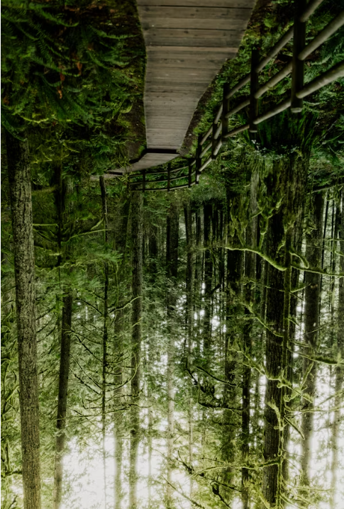

Virticle flip

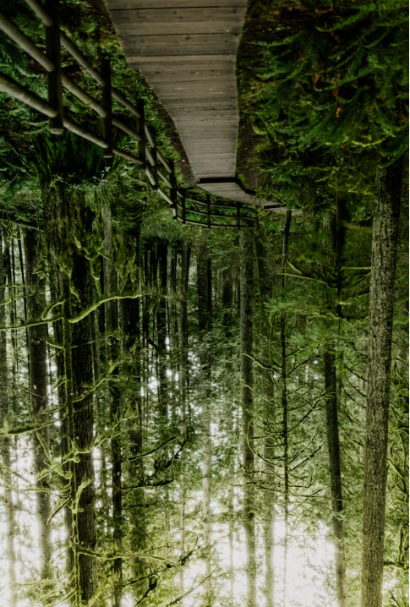

Flip horizontal

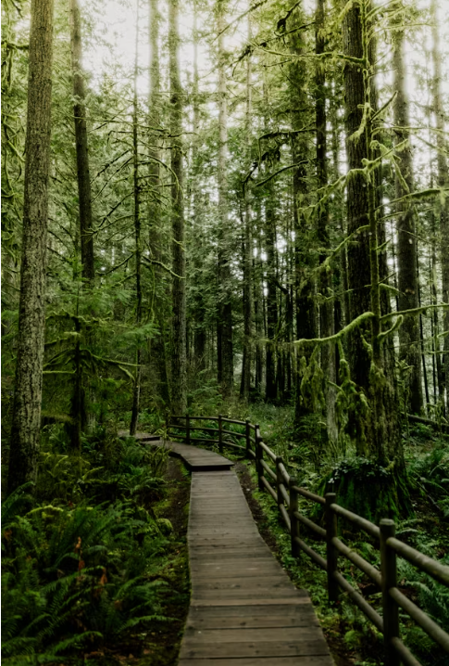

Flipped both horizontal and verticle



d. Image transpose

import cv2

image=cv2.imread('nature.png')

images = cv2.transpose(image)

cv2.imshow('Sample Image', images)

cv2.waitKey(0)

cv2.destroyAllWindows()

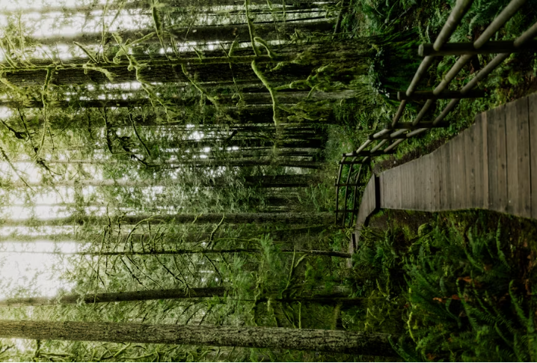

e. COLOR_BGR2GRAY

import cv2

image=cv2.imread('nature.png')

gray_image = cv2.cvtColor(image, cv2.COLOR_BGR2GRAY)

cv2.imshow('Sample Image', gray_image)

cv2.waitKey(0)

cv2.destroyAllWindows()

gry= cv2.cvtColor(image, cv2.COLOR_BGR2GRAY)

